HowTo Check Your OneDrive Storage Space

- Right-click on the OneDrive icon on your notification tray
- Click on Manage storage
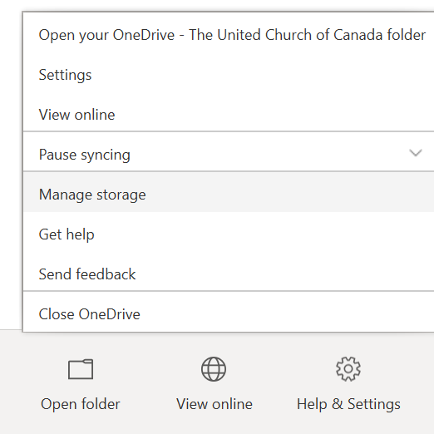
- When you click on Manage storage, a browser window will open titled Storage Metrics
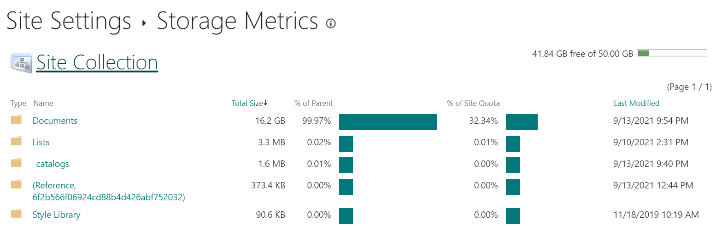
- Storage Metrics displays your total OneDrive storage in the top-right corner (50 GB) and how much free space remains (41.84 GB in the photo above – but will be different for each person). Storage Metrics also provides a breakdown of each folder and the total size of storage being utilized.

Understanding OneDrive Versioning and Storage Space

By default, versioning is enabled in OneDrive for all files under the Document folder. OneDrive keeps a minimum of 100 versions (default setting) as restore points. A new version is created when a file is modified.
Every version counts towards your OneDrives total storage space. In the example below, there are 16 versions. This 1.8 MB file will appear in OneDrive as a 28 MB file.
If a file is displaying incorrectly (too large in size) in the Storage Metircs, its best to check and delete its version history (instructions provided below). Once deleted, all previous version history is moved to the recycle bin. YOU MUST EMPTY YOUR RECYCLE BIN to free up your OneDrive storage space (files in the recycle bin still use OneDrive storage space, but won’t show up in the metrics report) (instructions provided below).
Versioning doesn’t play nicely with Outlook PST files. If you have PST files on your OneDrive, please check and delete the version history. These files will get massive in size.
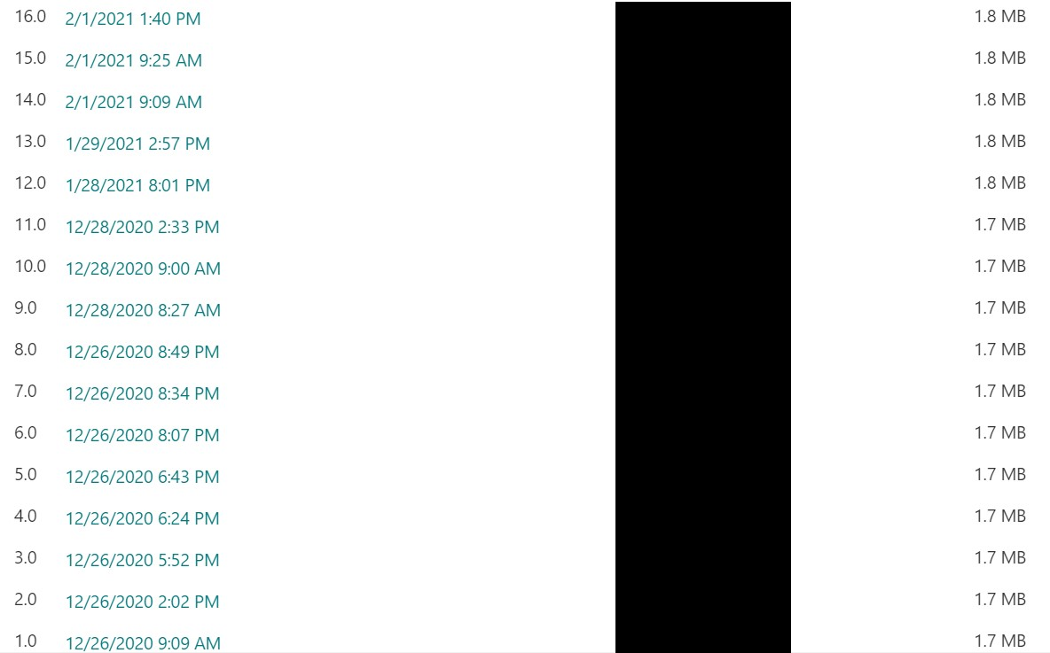

HowTo Delete OneDrive Version History (All Versions) for a File

- Launch Storage Metrics
- Click on the folders and navigate down until you reach your file
- Click on Version History
- Click on Delete All Versions
- You’ll receive a prompt to send all previous versions associated with file to the recycle bin. Click OK.
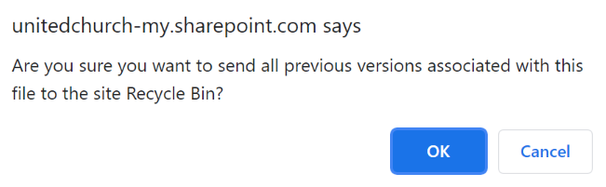
- All previous versions will be deleted and sent to the recycling bin. One version will remain.

HowTo Delete OneDrive Version History (Specific Version) for a File

- Launch Storage Metrics
- Click on the folders and navigate down until you reach your file
- Click on Version History
- Hover mouse over date/time of specific version and a drop-down menu becomes available. Click on drop-down menu click on delete.
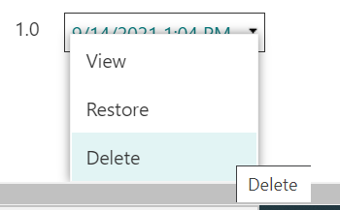
- You’ll receive a prompt to send this version to the recycling bin. Click OK.
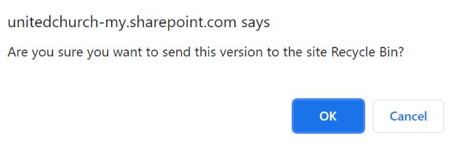
- This version will be deleted and sent to the recycling bin.

HowTo Empty Your Recycle Bin in OneDrive

- Right-click on the OneDrive icon on your notification tray
- Click on View online
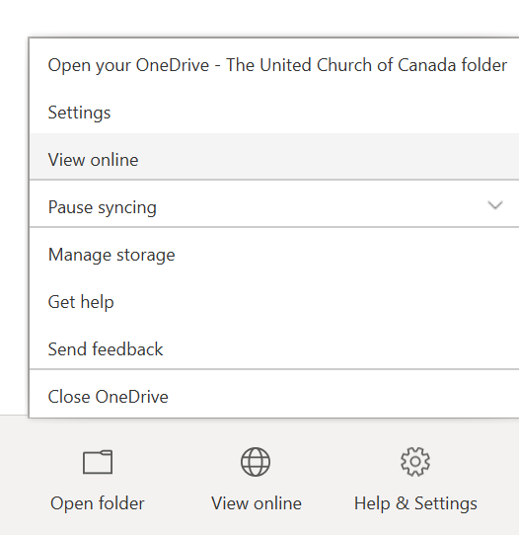
- Your OneDrive will open in a web browser
- On the left-hand side click on Recycle bin
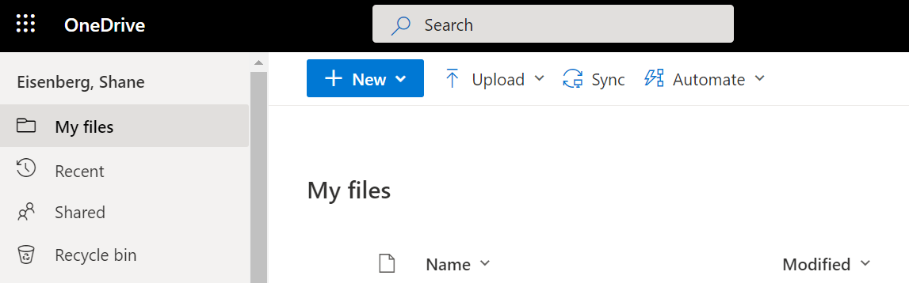
- Under Recycle bin, click on Empty recycle bin
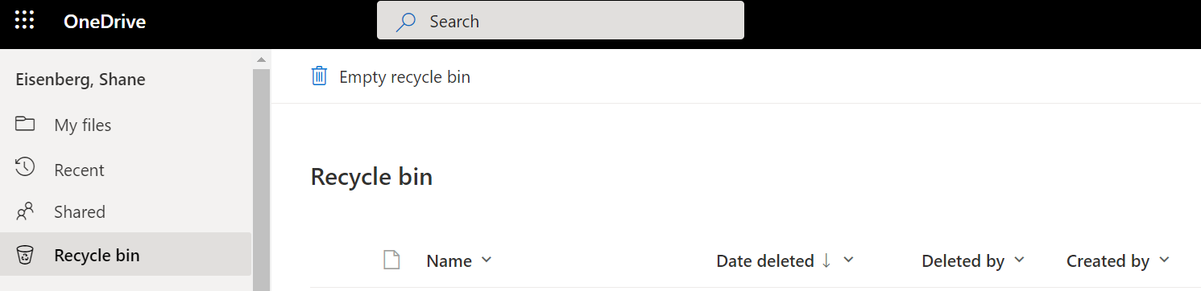
- You will receive a prompt to remove items from your recycle bin. Click Yes.
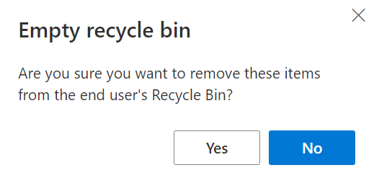
- Your recycle bin is now emptied.

